**TABLE OF SPECIFICATIONS FOR EXAM QUESTIONS**

**University of Liberal Arts Bangladesh**

**Department: Computer Science and Engineering (CSE)**

**Final Examinations, Semester: Fall 2020**

**Program: B.Sc. in CSE**

**Course Code: CSE480 Course Title: Web Technology Credit Hr: 3**

**Time: 2 Hours Total Marks: 25**

**Name & Designation of the Examiner: Satyaki Das, Lecturer**

**Learning Outcomes (LO):**

|  |
| --- |
| 1. **Recognize, recall** and **understand** latest practices and performance implications of client-side languages |
| 1. **Understand** and **outline** different processes for transmitting data |
| 1. **Design** and **develop** real-life Web Application |
| 1. **Use** available libraries, APIs and functions in Client-Side Language |
| 1. **Possess** positive approach to adapting and learning new languages/features and **apply** them to **create** interactive Web Applications |

***Levels in Bloom’s Cognitive Domain:***

***C1: Remember C2: Understand C3: Apply C4: Analyze C5: Evaluate C6: Create***

|  |  |  |  |  |  |  |  |
| --- | --- | --- | --- | --- | --- | --- | --- |
| **Question No.** | **Learning Outcomes (CO)** | **Level in Bloom’s Cognitive Domain along with Allocation of Marks** | | | | | |
|  |  | **C1** | **C2** | **C3** | **C4** | **C5** | **C6** |
| 1 | 2 |  | 7 |  |  |  |  |
| 2 | 2 |  | 2 | 6 |  |  |  |
| 3 | 4 |  |  | 5 |  |  |  |
| 4 | 4 |  | 5 |  |  |  |  |
| **Total Allocation of Marks** | **25** |  | 14 | 11 |  |  |  |
|  |  |  |  |  |  |  |  |
| **Question No.** |  | **Learning Outcome** | | | | | |
|  |  | **CO1** | **CO2** | **CO3** | **CO4** | **CO5** | **CO6** |
| 1 |  |  | 7 |  |  |  |  |
| 2 |  |  | 8 |  |  |  |  |
| 3 |  |  |  |  | 5 |  |  |
| 4 |  |  |  |  | 5 |  |  |
| **Total Allocation of Marks** | **25** |  | 15 |  | 10 |  |  |



**Signature of the Examiner Date: 12.01.2021**

**INSTRUCTIONS FOR THE FINAL EXAM  
PLEASE CAREFULLY READ THE FOLLOWING INSTRUCTIONS.**  
  
**During the Exam**

1. This is an “open note” exam that allows the students to use any materials handed out in the class, your notes from the lectures, and any other resource that I have already shared with you on Google Classroom.
2. The duration of the exam is 1 Hour 45 minutes and an additional 15 minutes is allotted for answer submission.
3. Show/present all the necessary steps/justifications to derive your answer, where applicable.
4. Showing or discussing anything related to the questions with anyone is prohibited. Hence, usage of any online and offline messaging platforms and external/cloud storage are also strictly prohibited. Further, online searches for preparing your answer are discouraged.
5. Plagiarism policy mentioned in the course outline will be followed.
6. During the entire exam period, you are required to be online over google meet. (The link will be the same as the link for regular classes).
7. You might be randomly asked to turn on your video during the exam. Hence, please ensure necessary arrangements to comply.
8. Please inform me immediately for any disruption via mobile/Whatsapp/FB Messenger.
9. Even if you have Broadband connection in your home, please purchase sufficient internet data on your smartphone to avoid any internet-related disruptions.

**Submission**

1. You must write down your answers on Blank A4 papers with a cover page that contains your Name, Student ID, Course Code, Course Title, Section Number, and “Final Exam- Fall2020”.
2. After completing the exam take pictures or scan your answer script. You may use any scanning app for this purpose.
3. Your student ID should be your file name.
4. Make sure that your handwriting is legible.
5. Questions you are answering must have their numbers written correctly.
6. Make sure that your answer scripts are correctly numbered and sequenced.
7. Upload the PDF file on Google Classroom within 15 minutes after the exam is complete.

Failure to submit the answers on time without any valid ground will be considered as late submission. Marks will be deducted in such cases.

**Department of Computer Science and Engineering**

**University of Liberal Arts Bangladesh**

**Final Examination (Fall 2020)**

**Course: Web Technology (CSE 480)**

**Section: 1 --- Duration: 1 Hour 45 Minutes**

**Name & Designation of the Examiner: Satyaki Das, Lecturer**

**______________________________________________________________________________________**

**PLEASE ANSWER ALL QUESTIONS. Total 25 Marks**

**QUESTION 1**

What are the different datatypes used for transmitting data? “XML must have one root key-value pair. JSON can have multiple.” Explain with an example. **(3+4=7 Marks)**

**QUESTION 2**

What are the different types of data you can transmit using routes in flask? How do you use dynamic elements in a Jinja template? Provide an example.

Consider the following python route:

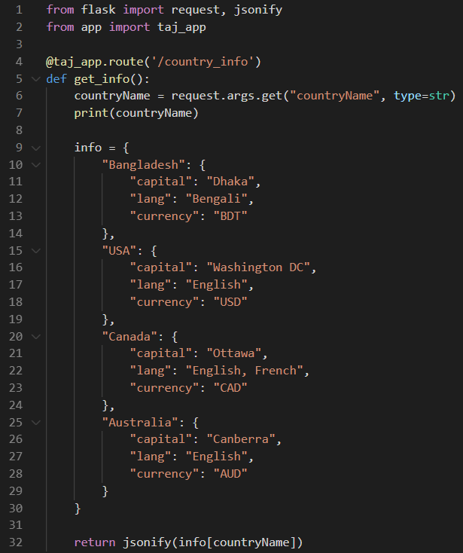

Now look at the results displayed when this route is called:

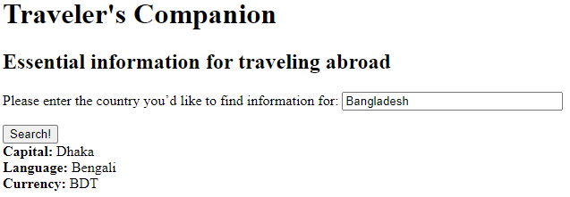

Write the code to display the Capital, Language and the Currency of the searched country. Use the flask templating syntax to display the information. **(2+3+3=8 Marks)**

**QUESTION 3**

Write a program (HTML and Javascript) with a button that counts the number of times it has been clicked and displays the result in a div. Instead of using Javascript DOM objects, use jQuery to perform the operation. **(5 Marks)**

**QUESTION 4**

Briefly discuss the steps of SSL encryption and how it prevents unauthenticated access to protected resources. **(3+2=5 Marks)**

**\*\*END OF QUESTIONS\*\***